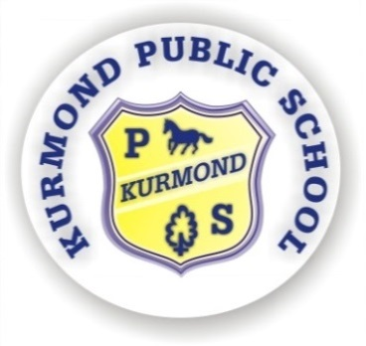
KURMOND PUBLIC SCHOOL
494 Bells Line of Road
Phone: 45731648
Fax: 45732122
Email: kurmond-p.school@det.nsw.edu.au

7th June, 2019
Kurmond Connect

Parent Information Session
How do we teach children to write?

Dear Parents,

We have scheduled our next parent information session for 2019 to be held on Tuesday 18th June at 6.30pm in the Library or Thursday 20th of June at 9.15am in The Library.

The same presentation will be presented at both sessions making it possible for interested parents to attend the evening session if you have work commitments during the day.
This is an excellent opportunity for parents to find out how we teach different Key Learning Areas first hand.

The session organised for this month is about Writing, specifically the strategies implemented from Kindergarten to Year 6 and how you can support children at home with their writing. It will be presented by Mrs Roberts. Toddlers welcome.

I hope to see you there.
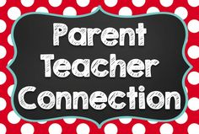

Kind Regards

Patricia Beggs
Principal

