KURMOND PUBLIC SCHOOL
494 Bells Line of Road
Phone: 45731648
Fax: 45732122
Email: kurmond-p.school@det.nsw.edu.au

Kurmond Connect – Visible Learning
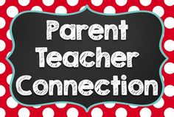
Tuesday 19th March, 2019 at 6.30pm

Or

Thursday 21st March 2019 at 9.20am

12th March, 2019
Dear Parents / Caregivers,
Our first parent information session has been scheduled for Tuesday 19th March at 6.30pm or Thursday 21st March at 9.20am in the Library.

The same presentation will be presented at both sessions making it possible for interested parents to attend the evening session if they have work commitments during the day. This is an opportunity for parents to find out how we are implementing Visible Learning principles into all our classrooms as part of the school’s strategic directions.

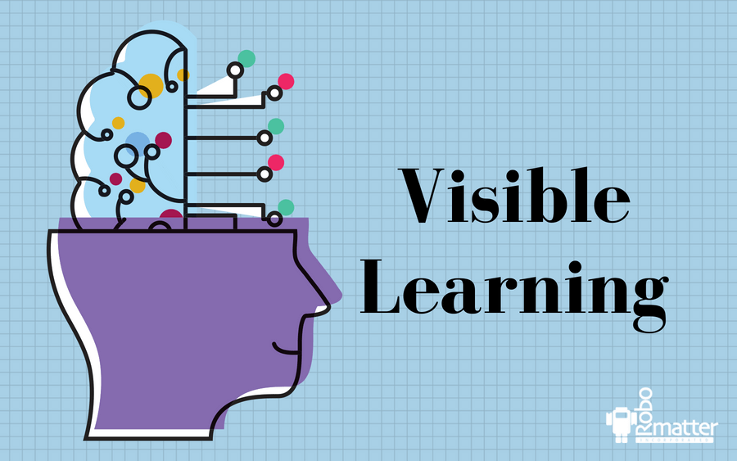
The session will introduce the following topics – Learner qualities, feedback, learning intentions and success criteria. I hope to see you there. Toddlers welcome.

Kind Regards

Patricia Beggs
Principal

