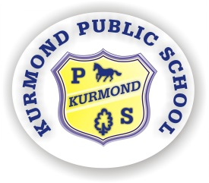
Kurmond Public School
Courtesy Safety Responsibility

494 Bells Line of Road KURMOND 2757 | P (02) 45731648 | F (02) 45732122 |
E kurmond-p.school@det.nsw.edu.au

14th November 2019

Dear Parents

PARENT INFORMATION SESSION
What’s the deal with coding?
Our next parent information session is scheduled for Tuesday 19th November at 6.30pm in the Library or Thursday 21st at 9.15am in ‘The Cottage’.

The same presentation will be presented at both sessions making it possible for interested parents to attend the evening session if they have work commitments during the day. The only difference being that part of the day session will also involve a practical visit to classrooms with students illustrating the concepts described during the information session. This is an opportunity for parents to find out how we teach different Key Learning Areas first hand.

The session organised for this month is about coding and the Digital Technologies strand of the Science and Technology syllabus. It will be presented by Mrs Palmer.

I hope to see you there. Toddlers welcome!

Kind regards.

Patricia Beggs
Principal

