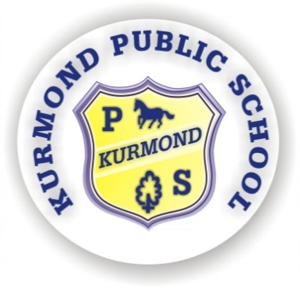
KURMOND PUBLIC SCHOOL
494 Bells Line of Road
Phone: 45731648
Fax: 45732122
Email: kurmond-p.school@det.nsw.edu.au

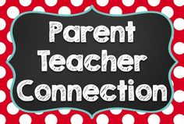
Kurmond Connect - Meet The Teacher

Wednesday 20th February, 2019

11th February 2019
Dear Parents and Caregivers,

We would like to invite you to our Kurmond Connect evening to be held on Wednesday 20th February 2019. This will be a great opportunity to meet and connect with your child’s teacher so you will be better informed on class routines, structures and learning for 2019.

Class teachers will be focusing on providing information on learning programs which will be implemented throughout the year, eg Words Their Way, TNT, Reading Comprehension Strategies, Quick Write and Visible Learning approaches. These are just some of the frameworks which are utilised at Kurmond to have maximum learning impact. Naturally, you will have the opportunity to ask questions of your child’s teacher during these sessions.

On the night, we will also be asking parents to fill out a class contact list, including phone numbers and email addresses, to assist with networking within the class. For example, this could include play dates, birthday parties, sharing pick up times, or asking for assistance with school activities such as the canteen or other events. It will be made available to all parents in the class for those who wish to add their details.

Below are the designated times and rooms for your child’s class:

Session | Class | Room
5:00 – 5:30pm | Lorikeets  Fairy Wrens  Kingfishers and Powerful Owls | Lorikeets  Fairy Wrens  Kingfishers
5.30 – 6:00 | Magpies  Bell Birds | Magpies  Bell Birds

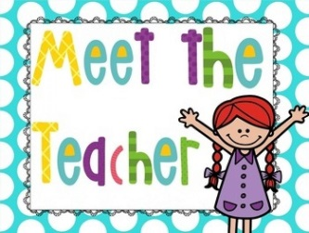
We look forward to meeting with you.

Kind Regards

Patricia Beggs
Principal

