Book Week Parade
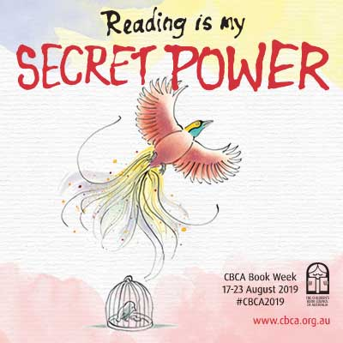
Thursday 22nd August
24th July 2019

Dear Parents and Carers,
Book Week is being held in Week 5 of Term 3. The students will be engaging with the short listed books during the beginning of this term, in classroom and library time.
The Book Character Parade will be held on Thursday 22nd August. The parade will begin at 2:15pm. Prizes will be awarded for the ‘best dressed’ in each class. We request that students bring a copy of the book that their character is from to carry during the parade.
Parents and relatives are welcome to come along and watch, or better still dress up. There will also be a sibling parade, where younger siblings can participate and show off their costumes and books too.
If you have any questions regarding this event please do not hesitate to contact me.
Kindest regards,
Rhiannon Roberts
Assistant Principal

Book Week Parade
Thursday 22nd August
24th July 2019

Dear Parents and Carers,
Book Week is being held in Week 5 of Term 3. The students will be engaging with the short listed books during the beginning of this term, in classroom and library time.
The Book Character Parade will be held on Thursday 22nd August. The parade will begin at 2:15pm. Prizes will be awarded for the ‘best dressed’ in each class. We request that students bring a copy of the book that their character is from to carry during the parade.
Parents and relatives are welcome to come along and watch, or better still dress up. There will also be a sibling parade, where younger siblings can participate and show off their costumes and books too.
If you have any questions regarding this event please do not hesitate to contact me.
Kindest regards,
Rhiannon Roberts
Assistant Principal

